- Strengths and Weaknesses of TF-IDF vs Semantic Embedding Similarity Score

- TF-IDF Cosine Similarity
- Interpretation: term weights TF-IDF = Term Frequency × Inverse Document Frequency. the higher the score, the more “they share terms that are both frequent within the specific documents and relatively rare across the entire collection of documents (corpus)”. In simple words, TF-IDF scores capture the “level” of shared keywords.
- Pros: High dimensional, sparse representations work best for medium sized corpora.
- Cons: shows surface level textual overlap; more suitable when documents describe the same idea using the same vocabulary, therefore it tends to underestimate when more diverse and complex vocabularies are used or when contexts are important.

- Semantic Embedding Cosine Similarity
- Interpretation: map documents into dense vectors using pre-trained language models, capturing cosine similarity between two “embedding vectors”.
- Pros: vectors are compact; encode contexts, word ordering, and semantic similarity such as synonyms and paraphrasing, better for nuanced texts.
- Cons: computationally intensive; works less effectively than TF-IDF with short keyword-heavy docs.

- Preliminary Results Interpretation

- Interpret TF-IDF Cosine Similarity

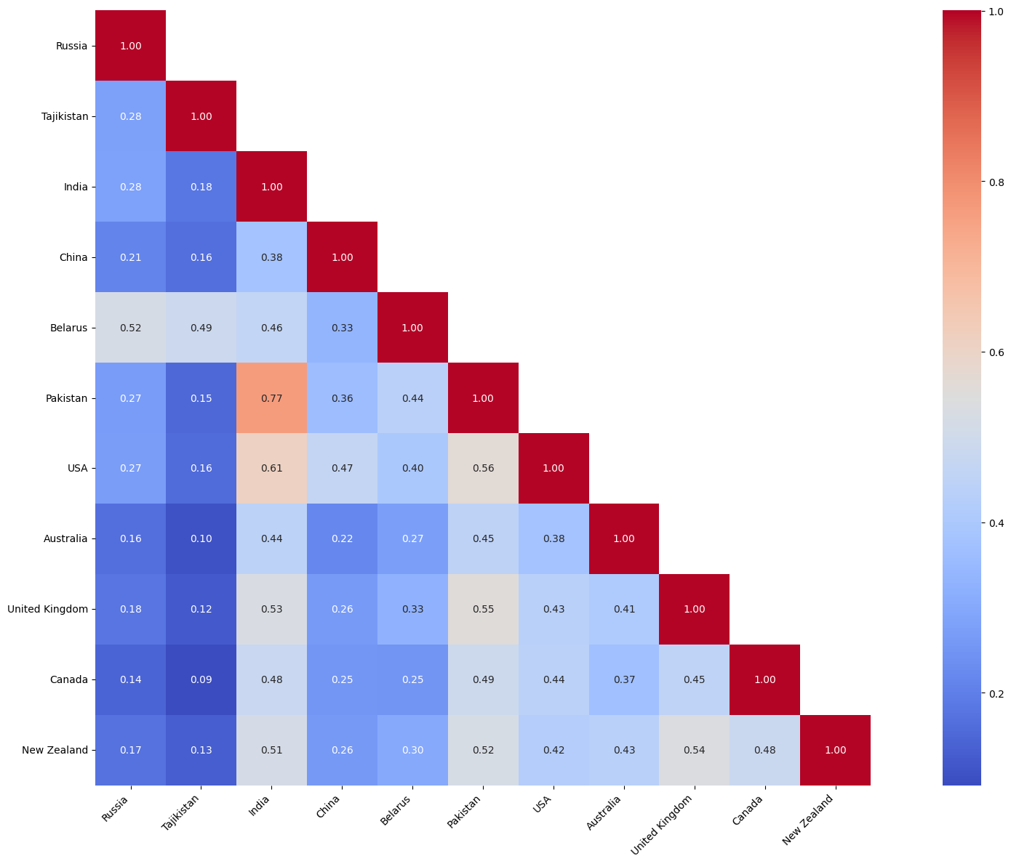

- Similarity scores are lower on average compared to Semantic Embedding.
- Examples of highest similarity: India and Pakistan with 0.77, USA and India with 0.61, Belarus and Russia with 0.52.
- TF-IDF shows surface-level textual overlap. Hence, overall, Five Eyes don’t look extremely similar in wording, but SCO countries show high similarity between certain pairs, including India–Pakistan and Russia–Belarus do.
- Countries where high similarity arises: Pakistan, USA, India, UK, New Zealand.

- Interpret Semantic Embedding Cosine Similarity

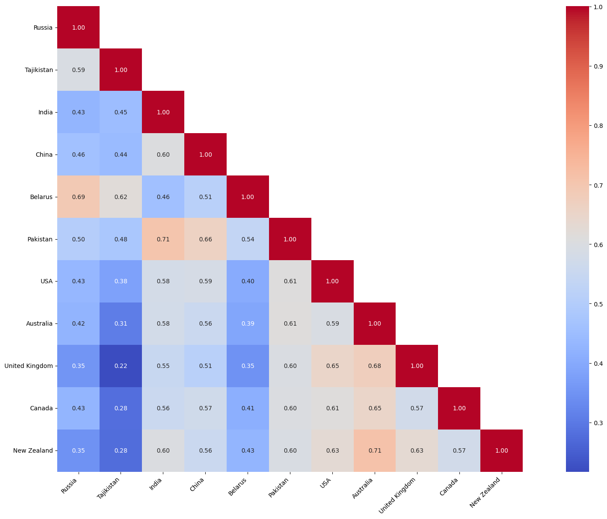
- Overall higher than TF-IDF.
- Same closely linked pairs arise again: India and Pakistan (0.71), Belarus and Russia (0.69), China and Pakistan (0.66).
- Five Eyes countries also show strong similarities. For instances, USA and UK 0.65, Australia and NZ 0.71, Canada and USA 0.61
- China shows high semantic similarity with many countries much more often than seen in TF-IDF.
- Five Eyes countries seem to show more agreement with each other while SCO countries show more variations.

